ROAD ACCIDENT REPORT SQL QUERIES
Primary KPI’s
CY Casualties
SELECT SUM(number_of_casualties) AS CY_Casualties FROM road_accident
WHERE YEAR(accident_date) = '2022'
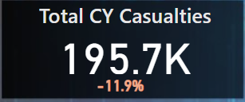
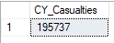

CY Accidents
SELECT COUNT(DISTINCT accident_index) AS CY_Accidents FROM road_accident
WHERE YEAR(accident_date) = '2022'
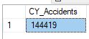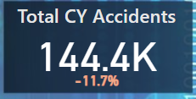
Fatal Casualties
SELECT SUM(number_of_casualties) AS CY__Fatal_Casualties FROM road_accident
WHERE YEAR(accident_date) = '2022' and accident_severity = 'Fatal'
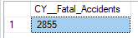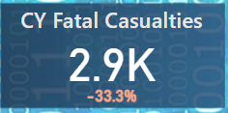
* Bonus For Excel which looks at total numbers by default instead of YoY numbers as PowerBI and Tableau does by default in these particular projects*
SELECT SUM(number_of_casualties) AS Fatal_Casualties, CAST(SUM(number_of_casualties)AS DECIMAL (10,2)) * 100/
(Select CAST(SUM(number_of_casualties) AS DECIMAL (10,2)) FROM road_accident) AS Fatal_PCT FROM road_accident
WHERE accident_severity = 'Fatal'
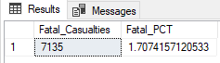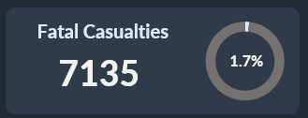

Serious Casualties
SELECT SUM(number_of_casualties) AS CY__Serious_Casualties FROM road_accident
WHERE YEAR(accident_date) = '2022' and accident_severity = 'Serious'
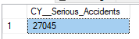
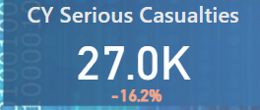

*Percentages, Bonus For Excel Which looks at Total numbers by default instead of YoY numbers as PowerBI and Tableau does by default in these particular projects*
SELECT SUM(number_of_casualties) AS Serious_Casualties, CAST(SUM(number_of_casualties)AS DECIMAL (10,2)) * 100/
(Select CAST(SUM(number_of_casualties) AS DECIMAL (10,2)) FROM road_accident) AS Serious_PCT FROM road_accident
WHERE accident_severity = 'Serious'
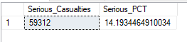 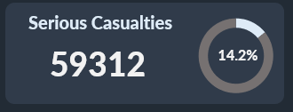
Slight Casualties
SELECT SUM(number_of_casualties) AS CY__Slight_Casualties FROM road_accident
WHERE YEAR(accident_date) = '2022' and accident_severity = 'Slight'
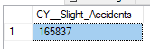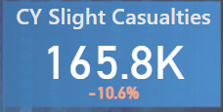
*Percentages, Bonus For Excel Which looks at Total numbers by default instead of YoY numbers as PowerBI and Tableau does by default in these particular projects*
SELECT SUM(number_of_casualties) AS Slight_Casualties, CAST(SUM(number_of_casualties)AS DECIMAL (10,2)) * 100/
(Select CAST(SUM(number_of_casualties) AS DECIMAL (10,2)) FROM road_accident) AS Slight_PCT FROM road_accident
WHERE accident_severity = 'Slight'
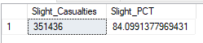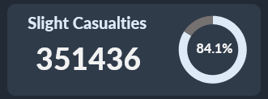
Secondary KPI’s
Casualties By Vehicle Type
SELECT
CASE
WHEN vehicle_type IN ('Agricultural vehicle') THEN 'Agricultural'
WHEN vehicle_type IN ('Car', 'Taxi/Private hire car') THEN 'Car'
WHEN vehicle_type IN ('Motorcycle 125cc and under', 'Motorcycle 50cc and under', 'Motorcycle over 125cc and up to 500cc', 'Motorcycle over 500cc', 'Pedal cycle') THEN 'Bike'
WHEN vehicle_type IN ('Bus or coach (17 or more pass seats)', 'Minibus (8 - 16 passenger seats)') THEN 'Bus'
WHEN vehicle_type IN ('Goods 7.5 tonnes mgw and over', 'Goods over 3.5t. and under 7.5t', 'Van / Goods 3.5 tonnes mgw or under') THEN 'Van'
ELSE 'Other'
END AS vehicle_group,
SUM(number_of_casualties) AS CY_Casualties
FROM road_accident
WHERE YEAR (accident_date) = '2022'
GROUP BY
CASE
WHEN vehicle_type IN ('Agricultural vehicle') THEN 'Agricultural'
WHEN vehicle_type IN ('Car', 'Taxi/Private hire car') THEN 'Car'
WHEN vehicle_type IN ('Motorcycle 125cc and under', 'Motorcycle 50cc and under', 'Motorcycle over 125cc and up to 500cc', 'Motorcycle over 500cc', 'Pedal cycle') THEN 'Bike'
WHEN vehicle_type IN ('Bus or coach (17 or more pass seats)', 'Minibus (8 - 16 passenger seats)') THEN 'Bus'
WHEN vehicle_type IN ('Goods 7.5 tonnes mgw and over', 'Goods over 3.5t. and under 7.5t', 'Van / Goods 3.5 tonnes mgw or under') THEN 'Van'
ELSE 'Other'
END
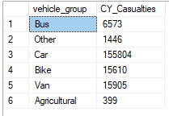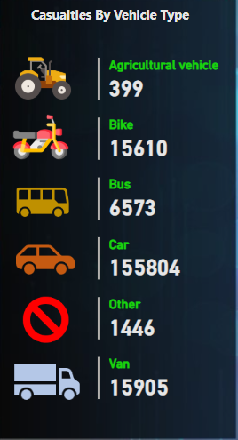

CY Casualties vs PY Casualties Monthly Trend
SELECT DATENAME(MONTH, accident_date) AS Month_Name, SUM(number_of_casualties) AS CY_Casualties
FROM road_accident
WHERE YEAR (accident_date) = '2022'
GROUP BY DATENAME(MONTH, accident_date)

SELECT DATENAME(MONTH, accident_date) AS Month_Name, SUM(number_of_casualties) AS PY_Casualties
FROM road_accident
WHERE YEAR (accident_date) = '2021'
GROUP BY DATENAME(MONTH, accident_date)
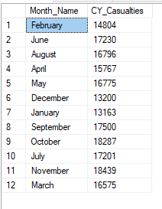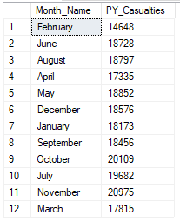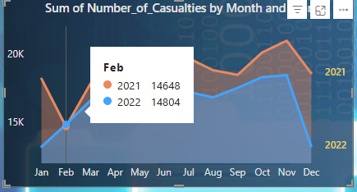

CY Casualties by Road Type
SELECT road_type, SUM(number_of_casualties)AS CY_Casualties
FROM road_accident
WHERE YEAR (accident_date) = '2022'
GROUP BY road_type
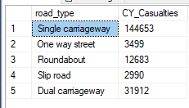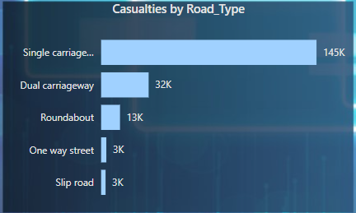

CY Casualties by Urban/Rural
SELECT urban_or_rural_area, SUM(number_of_casualties) AS CY_Casualties, CAST(SUM(number_of_casualties) AS DECIMAL (10,2)) * 100/
(SELECT CAST(SUM(number_of_casualties) AS DECIMAL (10,2)) FROM road_accident WHERE YEAR (accident_date) = '2022')
AS CY_Casualties_PCT
FROM road_accident
WHERE YEAR (accident_date) = '2022'
GROUP BY urban_or_rural_area
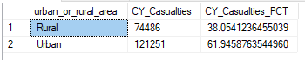 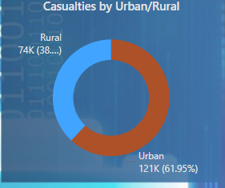
*Bonus For Excel Which looks at Total numbers by default instead of YoY numbers as PowerBI and Tableau does by default in these particular projects*
SELECT urban_or_rural_area, SUM(number_of_casualties) AS Casualties, CAST(SUM(number_of_casualties) AS DECIMAL (10,2)) * 100/
(SELECT CAST(SUM(number_of_casualties) AS DECIMAL (10,2)) FROM road_accident) --WHERE YEAR (accident_date) = '2022')
AS Casualties_PCT
FROM road_accident
--WHERE YEAR (accident_date) = '2022'
GROUP BY urban_or_rural_area

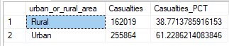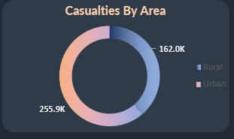

CY Casualties by Light Condition
SELECT
CASE
WHEN light_conditions IN ('Daylight') THEN 'Day'
WHEN light_conditions IN ('Darkness - lighting unknown', 'Darkness - lights lit', 'Darkness - lights unlit', 'Darkness - no lighting') THEN 'Night'
END AS light_conditions,
SUM(number_of_casualties) AS CY_Casualties,
CAST(CAST(SUM(number_of_casualties) AS DECIMAL(10,2)) * 100 /
(SELECT CAST(SUM(number_of_casualties) AS DECIMAL (10,2)) FROM road_accident WHERE YEAR(accident_date) = '2022') AS DECIMAL(10,2))
AS CY_Casualties_PCT
FROM road_accident
WHERE YEAR (accident_date) = '2022'
GROUP BY
CASE
WHEN light_conditions IN ('Daylight') THEN 'Day'
WHEN light_conditions IN ('Darkness - lighting unknown', 'Darkness - lights lit', 'Darkness - lights unlit', 'Darkness - no lighting') THEN 'Night'
END
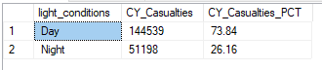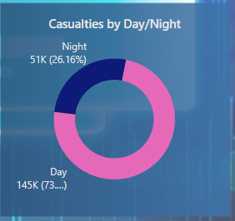
*Bonus For Excel Which looks at Total numbers by default instead of YoY numbers as PowerBI and Tableau does by default in these particular projects*
SELECT
CASE
WHEN light_conditions IN ('Daylight') THEN 'Day'
WHEN light_conditions IN ('Darkness - lighting unknown', 'Darkness - lights lit', 'Darkness - lights unlit', 'Darkness - no lighting') THEN 'Night'
END AS light_conditions,
SUM(number_of_casualties) AS Casualties,
CAST(CAST(SUM(number_of_casualties) AS DECIMAL(10,2)) * 100 /
(SELECT CAST(SUM(number_of_casualties) AS DECIMAL (10,2)) FROM road_accident) AS DECIMAL(10,2))
AS Casualties_PCT
FROM road_accident
--WHERE YEAR (accident_date) = '2022'
GROUP BY
CASE
WHEN light_conditions IN ('Daylight') THEN 'Day'
WHEN light_conditions IN ('Darkness - lighting unknown', 'Darkness - lights lit', 'Darkness - lights unlit', 'Darkness - no lighting') THEN 'Night'
END

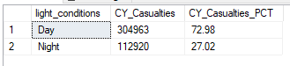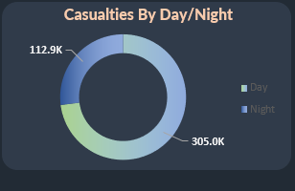

Top 10 Locations by No. of Casualties
SELECT TOP 10 local_authority, SUM(number_of_casualties) AS Total_Casualties
FROM road_accident
GROUP BY local_authority
ORDER BY Total_Casualties DESC
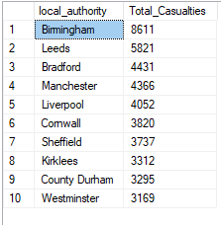 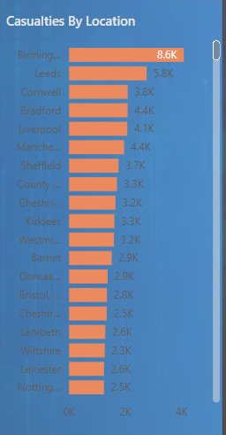

CY Casualties by Road Surface
SELECT
CASE
WHEN road_surface_conditions IN ('Dry') THEN 'Dry'
WHEN road_surface_conditions IN ('Wet or damp', 'Flood over 3cm. deep') THEN 'Wet'
WHEN road_surface_conditions IN ('Frost or ice', 'Snow') THEN 'Snow or Ice'
END AS road_surface_conditions,
SUM(number_of_casualties) AS CY_Casualties,
CAST(CAST(SUM(number_of_casualties) AS DECIMAL(10,2)) * 100 /
(SELECT CAST(SUM(number_of_casualties) AS DECIMAL (10,2)) FROM road_accident WHERE YEAR(accident_date) = '2022') AS DECIMAL(10,2))
AS CY_Casualties_PCT
FROM road_accident
WHERE YEAR (accident_date) = '2022'
GROUP BY
CASE
WHEN road_surface_conditions IN ('Dry') THEN 'Dry'
WHEN road_surface_conditions IN ('Wet or damp', 'Flood over 3cm. deep') THEN 'Wet'
WHEN road_surface_conditions IN ('Frost or ice', 'Snow') THEN 'Snow or Ice'
END

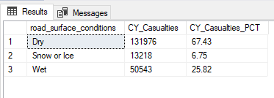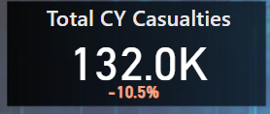

*Bonus For Excel Which looks at Total numbers by default instead of YoY numbers as PowerBI and Tableau does by default in these particular projects*
SELECT
CASE
WHEN road_surface_conditions IN ('Dry') THEN 'Dry'
WHEN road_surface_conditions IN ('Wet or damp', 'Flood over 3cm. deep') THEN 'Wet'
WHEN road_surface_conditions IN ('Frost or ice', 'Snow') THEN 'Snow or Ice'
END AS road_surface_conditions,
SUM(number_of_casualties) AS CY_Casualties,
CAST(CAST(SUM(number_of_casualties) AS DECIMAL(10,2)) * 100 /
(SELECT CAST(SUM(number_of_casualties) AS DECIMAL (10,2)) FROM road_accident) AS DECIMAL(10,2))
AS CY_Casualties_PCT
FROM road_accident
--WHERE YEAR (accident_date) = '2022'
GROUP BY
CASE
WHEN road_surface_conditions IN ('Dry') THEN 'Dry'
WHEN road_surface_conditions IN ('Wet or damp', 'Flood over 3cm. deep') THEN 'Wet'
WHEN road_surface_conditions IN ('Frost or ice', 'Snow') THEN 'Snow or Ice'
END

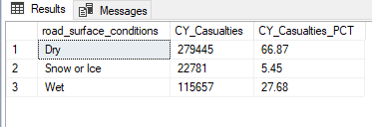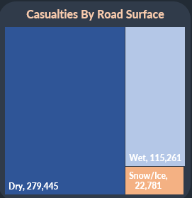

CY Casualties by Weather Conditions
SELECT
CASE
WHEN weather_conditions IN ('Fine + high winds', 'Fine no high winds') THEN 'Fine'
WHEN weather_conditions IN ('Raining + high winds', 'Raining no high winds') THEN 'Rain Weather'
WHEN weather_conditions IN ('Fog or mist', 'Snowing + high winds', 'Snowing no high winds') THEN 'Snow or Fog'
ELSE 'Other'
END AS weather_conditions,
SUM(number_of_casualties) AS CY_Casualties,
CAST(CAST(SUM(number_of_casualties) AS DECIMAL(10,2)) * 100 /
(SELECT CAST(SUM(number_of_casualties) AS DECIMAL (10,2)) FROM road_accident WHERE YEAR(accident_date) = '2022') AS DECIMAL(10,2))
AS CY_Casualties_PCT
FROM road_accident
WHERE YEAR (accident_date) = '2022'
GROUP BY
CASE
WHEN weather_conditions IN ('Fine + high winds', 'Fine no high winds') THEN 'Fine'
WHEN weather_conditions IN ('Raining + high winds', 'Raining no high winds') THEN 'Rain Weather'
WHEN weather_conditions IN ('Fog or mist', 'Snowing + high winds', 'Snowing no high winds') THEN 'Snow or Fog'
ELSE 'Other'
END

